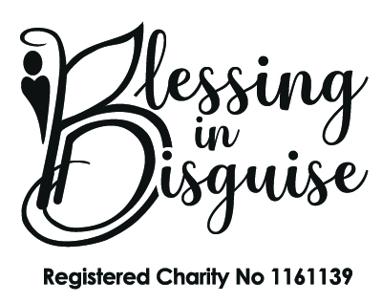
Cost of Living Pack Feedback Form
We hope that you found the Cost of Living pack beneficial. We would be very grateful if you could please provide some feedback and answer the questions below. This feedback is vital to the continuation of the project. Failure to provide feedback may result in your registration being suspended until feedback is provided. This means that you will not be able to apply for further support, tickets for events or apply for equipment. Thank you.
Section 1 - Contact Details
Parent / Family Names:
Address:
Post Code:
Contact Numbers: | Home: | Mobile:
Email:

Section 2 – Children’s details

Registered Child’s Full Name |  | D.O.B:

Section 3 – Please answer all questions
How did you find out about the cost of living packs?
How did you find the application process?
How did the cost of living pack help your family? (please answer in detail)
What items where most helpful?
What items would you like to see in future packs that you think would help others?
How could we improve this service?
Would you recommend the service to others?
Would you like further information on organisations who may be able to offer further support and advice? YES /NO

Thank you for taking the time to fill in this feedback form. All information given will be treated as anonymous.
Sign or Type Name:
Date:

