Cost of living support parcel application form
B.I.D. Reg.
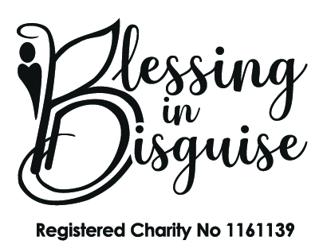

Return completed form to: B.I.D. OFFICE USE ONLY:
Initial
Blessing in Disguise | Received: | Date:
Lilford House St. Helens Rd | Method: | Email / Post / Facebook
Leigh | Director Decision: | Approve / Decline
WN7 4HG

Section 1 - Contact Details
Parent / Family Names:
Address:
Post Code:
Contact Numbers: | Home: | Mobile:
Email:

Section 2 – Children’s details

Registered Child’s Full Name |  | D.O.B:
Number of Siblings | M | F

Section 3 – Meeting Blessing in Disguise’s Criteria
Eligibility criteria must be met. Family must be on a low income and receive two or more of the following benefits. .

Please tick all that apply
 | Child Benefit |  | Working Tax Credit |  | Disability Living Allowance (DLA)
 | Income Support |  | Universal Credit |  | Job Seekers Allowance (JSA)
 | Other |  | Housing Benefit |  | Personal Independence Payment (PIP)

Please answer ALL questions below in detail

Have you accessed any welfare support from any other services such as local council, citizen’s advice or similar charities? YES / NO

If yes, what support have you received?
Would you like further information on organisations who may be able to offer further support and advice? YES / NO

How has the cost of living crisis affected your family?
What essential items have you had to cut back on to make ends meet?
Why do you feel your family need a welfare pack?
If your application is successful how would a welfare pack make a difference to your family?

Have you had any equipment grant in the last 3 years? Yes No

By submitting this application you are agreeing to give feedback about the Cost of living pack. Failure to provide feedback when requested may result in your registration with Blessing in Disguise being suspended until feedback is received. This means that you will not be able to apply for further support, tickets for events or equipment. We require this feedback so that we can demonstrate the impact of the project to funders and the wider community.

Completed forms must be returned by email to: blessingsindisguisecharity@gmail.com

Post:
Blessing in Disguise,
Lilford House,
St Helens Road,
Leigh,
WN7 4HG

Or via our Facebook Messenger at
https://www.facebook.com/BlessingsInDisguise.UK

